Assignment #4 SAS Enterprise Miner

**CLUSTERING**

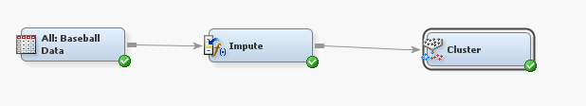

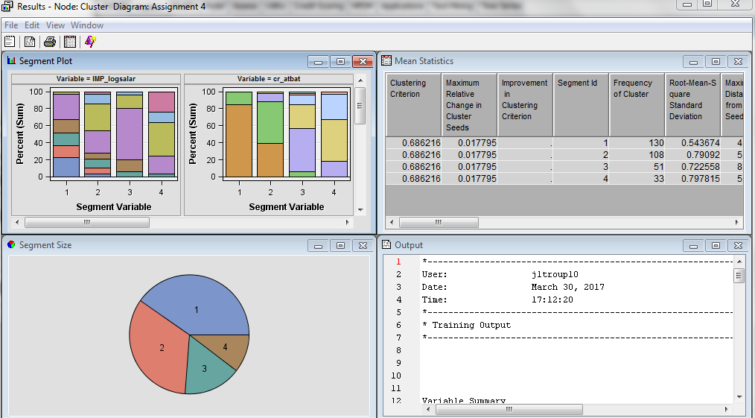

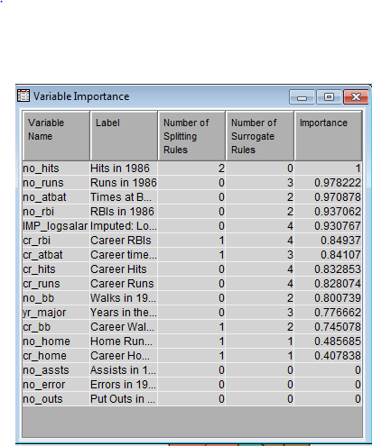

**No_Hits variable is very important with a value of 1. Variable 2-14 are significant variables. No_Assts, No_Error, and No_Outs have a value of 0 importance and are not used by the Cluster node.**

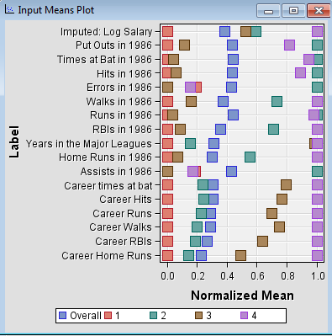

**The visual graph above shows the in cluster mean for cluster 1 is less than the overall mean while cluster 4 is always greater. Cluster 2 & 3 means vary between the overall mean. Cluster 1 are younger players earning a below average salary with their career statistics below average. Cluster 4 shows the veteran players with above average salaries and career statistics. Cluster 2 & 3 is a variety of players with good and poor statistics and varying salaries.**

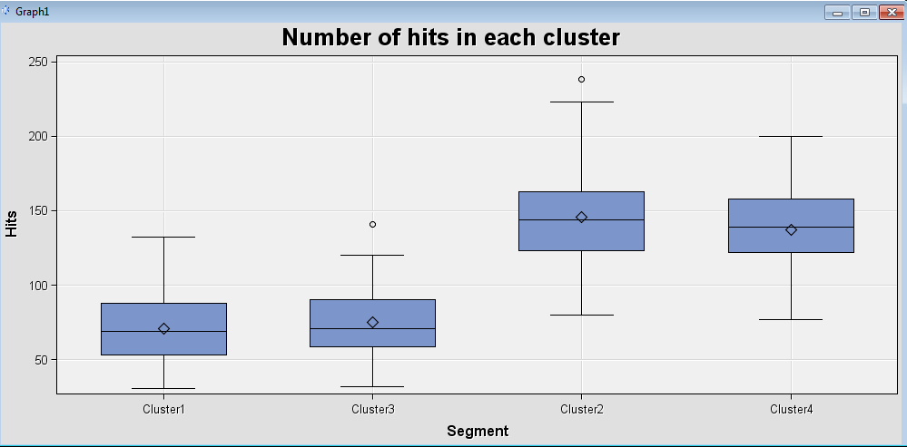

**The plot graph shows the average number of hits in lower in cluster 1 & 3. Cluster 2 & 4 have a much higher average number of hits.**

**ASSOCIATION RULES**

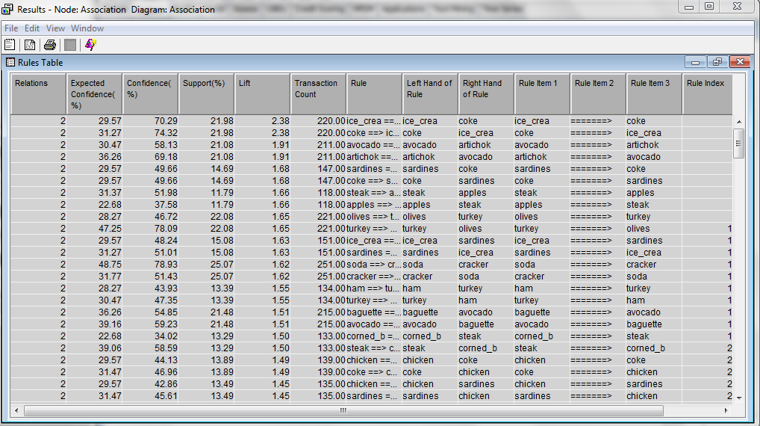

**The top two rules with the greatest Support % are heineken🡺cracker and cracker🡺heineken with a 36.56%. These rules are stating 36.56% of all customer purchased beer and crackers together. The confidence percentage of heineken🡺cracker is 61% which shows a considerably high percentage of people who bought beer with crackers. The second rule indicates a 75% confidence percentage. Both of these rules correlate with each other as they’re the same products. Both of these rules have a 1.25 Lift which is greater than 1 indicating a positive association or a “good” rule. The first two rules have the greatest lift of 2.38 when coke is purchased with ice cream.**